Census Jobs Social Media Content

This material is from the 2020 Census Recruitment Toolkit provided by the Census Bureau. A copy of the full booklet can be found on the Marin Census 2020 website (2020 Census Recruitment Toolkit). We have moved them into this document to make it easier to copy and paste to your social media channels.
Here are sample posts you can use on your social media channels, or add as a personal touch to assist us with promoting 2020 Census jobs and our recruiting efforts.

Facebook

Option 1
Every 10 years, the U.S. Census Bureau is responsible for conducting the nationwide census. While the next census will be taken in 2020, the Census Bureau is already recruiting to fill important temporary positions. Apply online at 2020census.gov/jobs.
#2020CensusJobs #ApplyToday
Recommended image to post with this copy:
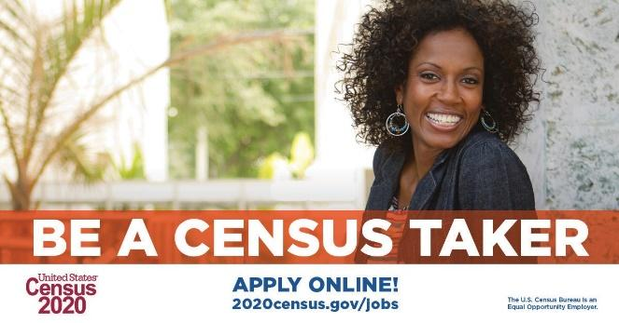

Option 2
You can help your community! Apply for one of thousands of temporary #2020CensusJobs. Census results determine the number of seats each state has in the U.S. House of Representatives as well as how funds are spent on roads, schools and hospitals.
Apply online at 2020census.gov/jobs. #ApplyToday
Recommended image to post with this copy:
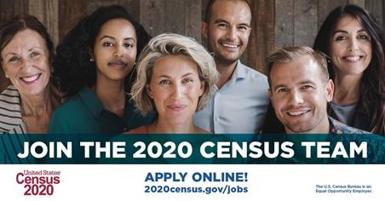

Instagram

Option 1
Be a Census Taker and make a difference in your community. Click link in bio to learn more and apply, or visit our Website: 2020census.gov/jobs.
#2020CensusJobs #ApplyOnline
Recommended image to post with this copy:

Option 2
The U.S. Census Bureau is recruiting for #2020CensusJobs. Click link in bio to learn more and apply, or visit our Website: 2020census.gov/jobs.
#ApplyOnline
Recommended image to post with this copy:
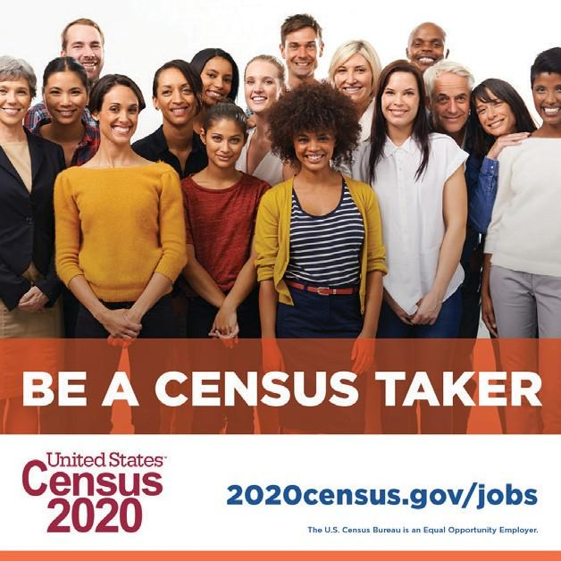

LinkedIn

Option 1
The census will be taken in 2020, but the U.S. Census Bureau is already recruiting to fill important temporary positions. Join the 2020 Census team by applying online at 2020census.gov/jobs. #2020CensusJobs #ApplyNow
Recommended image to post with this copy:

Option 2
You can help your community by applying for a temporary 2020 Census job. The pay is competitive. You will be paid weekly, and the hours are flexible. The U.S. Census Bureau is recruiting now. Apply online at 2020census.gov/jobs. #2020CensusJobs #ApplyNow
Recommended image to post with this copy:

Twitter

Option 1
The U.S. Census Bureau is now recruiting for thousands of 2020 Census Takers. Apply online for a temporary job at 2020census.gov/jobs. #2020CensusJobs #ApplyNow
Recommended image to post with this copy:
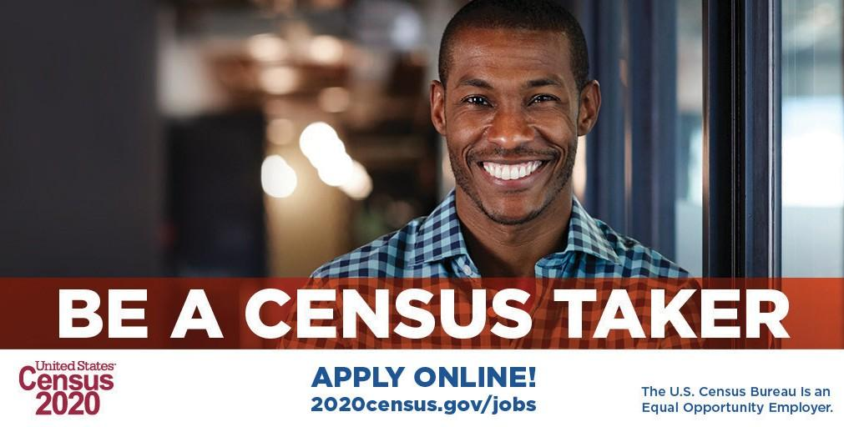

Option 2
You can make a difference and help your community by applying for a temporary 2020 Census job. Responses to the census make a real difference. Apply online at 2020census.gov/jobs.
Recommended image to post with this copy:
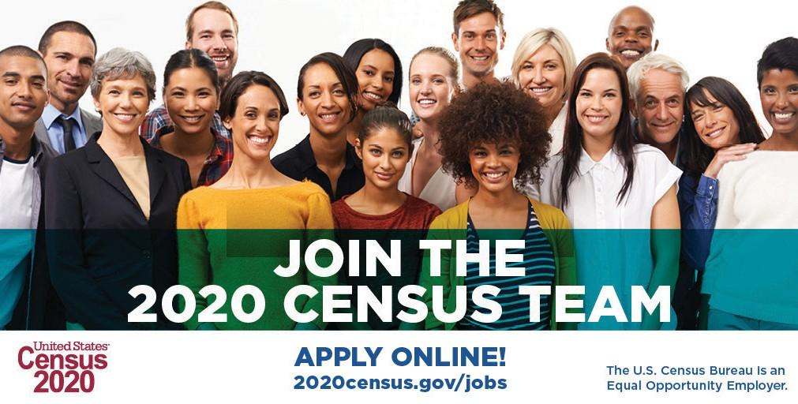

Sample Email Messages

Sample Email #1
Subject Line: The U.S. Census Bureau is Hiring in Our Area!
Are you looking for ways to help your community? The U.S. Census Bureau is currently hiring temporary positions for the 2020 Census in our area.
All 2020 Census jobs are temporary. The largest number of positions available are for census takers. Pay rates vary by area.
By working for the Census Bureau, you can help them reach their goal for the 2020 Census to ensure everyone is counted. Census counts have a huge impact on our community. The 2020 Census data will be used to determine how more than $675 billion from more than 100 government programs are distributed to states and localities, including communities like ours. The data influence choices made about which roads are fixed, where schools are built and businesses opened, what medical services are offered, and more.
If you’re interested, please visit the Census Bureau job site to apply. You’ll also be able to see the descriptions and frequently asked questions at 2020census.gov/jobs.
Sincerely,
[Your name and contact information here]

Sample Email #2
Subject Line: Help your community: Work for the U.S. Census Bureau!
The U.S. Census Bureau is currently hiring for the 2020 Census. The positions are temporary with varying pay ranges. For Census Takers, the pay starts at $25.00 – $27.50/hour.
By working for the Census Bureau, our community has a special opportunity to help make the 2020 Census an accurate and complete count. There are so many reasons our nation needs to be counted completely and accurately. The count happens every 10 years with the decennial census, which influences how more than $675 billion from more than 100 federal programs are distributed to states and localities each year. Here’s some of what the census numbers effect:
- Medicaid
- School lunch programs
- Community development grants
- Road and school construction
- Medical services
- Business locations

If you’re interested in a job, please visit the Census Bureau job site to apply. You’ll also be able to see the descriptions and frequently asked questions at 2020census.gov/jobs.
Feel free to forward this email to someone in your network who may be looking for a job. Working for the Census Bureau is a unique opportunity!
Sincerely,
[Your name and contact information here]

